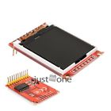**1.44" TFT SPI Serial Module LCD Colorful Display 128\*128**

Article-Nr.:5401105

Product Details: 1.44" TFT SPI Serial Module

Condition: New

With PCB baseboard

Dot matrix: 128X128

Driver: ST7735

Can drive with four IO

Support Arduino

Color is shown as pictures

PLS NOTE that due to lighting effects, monitor's brightness / contrast settings etc, there could be some slight differences in the color tone of the pictures and the actual item!

Package Included:

1 x 1.44" TFT SPI Serial Module